

LAWN CARE TIME TABLE

Fertilizing your lawn regularly is the most important step in growing a healthy attractive lawn. It promotes a strong thick sod to absorb and trap moisture and lawn care products. This keeps undesirable substances from leaching into water supplies.

In some cases, insecticides and herbicides can be reduced by adopting a regular fertilizing program. This is why we do not promote a fixed “4 step” program that assumes the use of insecticides and herbicides are necessary. More, we are of the Integrated Pest Management school of thought. IPM is the philosophy that promotes the responsible use of pesticides, using only when necessary.

Do not assume that you have a grub problem without investigating first. Apply pesticides at the correct time to increase their effectiveness.
Consider using fertilizers to help compete with unwanted weeds.

April – May

First Fertilization

Maintenance Fertilizer with or without Pre-emergent for crabgrass prevention.
Pre-emergent should be timed with the budding of the forsythia bushes.

Products: TEAM or 16-0-8 with TEAM PRO or 20-0-4 with Mesotrione

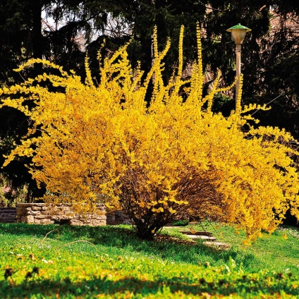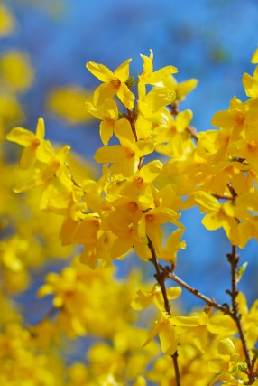

Grub Damage

If there is grub damage from last fall an application of Dylox will help control them. They are harder to kill at this time of the season, so you may wish to wait until mid-September to treat them.
The Grubex can be put down mid-May to mid-June for season long grub control.

Products: Dylox – kills on contact or Grubex – season long control.

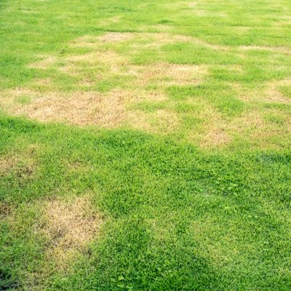

June

Second Fertilization

Maintenance Fertilizer with or without Post-emergent for broadleaf weeds, such as dandelions, chickweed and plantain. The 19-0-6 post-emergent must be applied on a wet lawn with no rain or irrigation for 24 – 48 hrs. The 20-0-7 and the 20-0-4 should be watered in.

Products: With weed control - 19-0-6 with LOCKUP or 20-0-7 with TRIMEC or the 20-0-4 with Mesotrione.
Without weed control – 25-0-12 or 29-0-10.

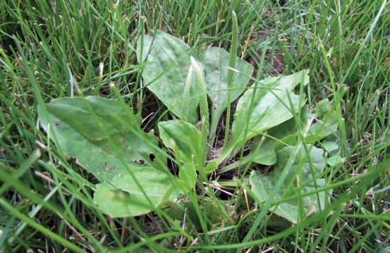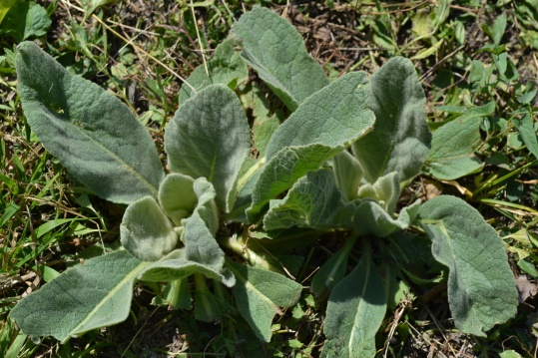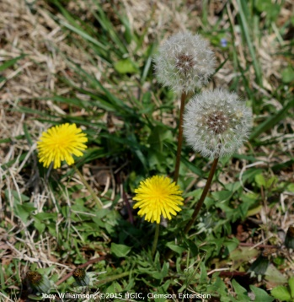

July – August

Let It Lie In July

Keeping your lawn at a height of at least 3” will help it tolerate the usual droughts of summer. If you do not have an irrigation system, we recommend that you leave your lawn long, and do not treat with any products that may further add to the stress it is already experiencing with the heat of summer. You can take a break from mowing as well if the lawn has gone fully dormant, and enjoy the summer!

Products: None

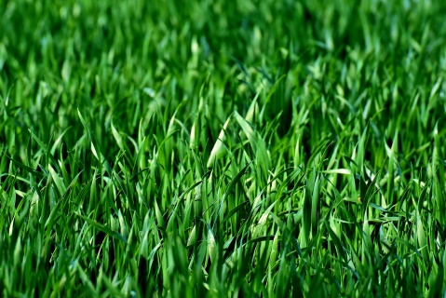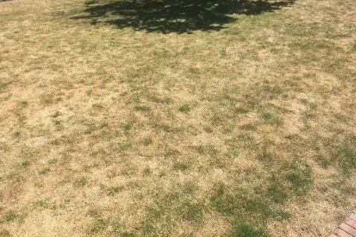

September

Third Fertilization

Maintenance Fertilizer with or without Post-emergent for broadleaf weeds.

Products: With weed control - 19-0-6 with LOCKUP or 20-0-7 with TRIMEC or the 20-0-4 with Mesotrione.
Without weed control – 25-0-12 or 29-0-10.

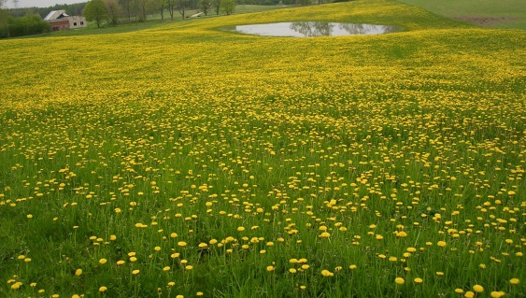

Grub Control

If dead sod was found in the spring, it is usually a signal that there is grub damage. Look for sod that lifts off in large pieces.

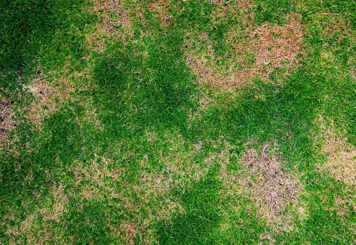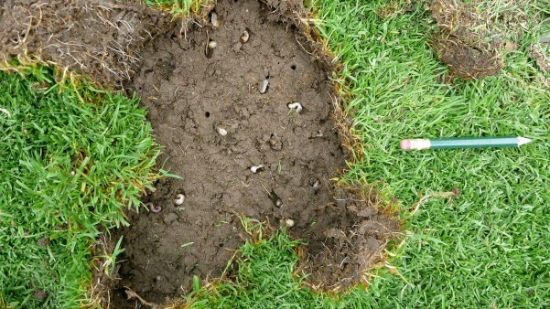

Dylox applied mid-September to mid-October will target the young grubs hatching before they do much damage to lawn. Item is most effective when it is watered in as soon as possible.

October – November

Maintenance or Winter Fertilizer after the last mowing of the season.

Products: 25-0-12 or 29-0-10.

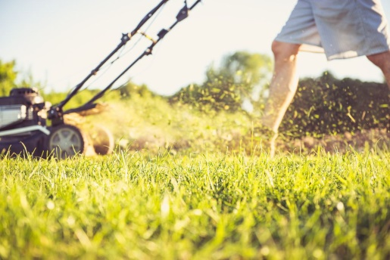

NEW OR OVER-SEEDED LAWNS

- It is recommended by Cornell University to apply a Starter Fertilizer whenever seeding. The phosphorous (P) in the fertilizer is more soluble which makes it easier for the new seedlings to absorb. This will help to encourage a secondary blade and root structure to develop more quickly.

- Remember, weed control in any form cannot be used on young grass seedlings.

- The Lebanon 21-22-4 with Mesotrione can be used when planting seed, which will control weeds and allow your seed to germinate.

- Standard Broadleaf weed control can be used after the 4th mowing or 4-5 weeks before seeding.

